**CP Club 365Days Challenge**

**Date – 28/11/2022**

**Programming language – Your preferred programming language**

**Problem Statement**

**<hackerrank.com/challenges/hackerrank-in-a-string/problem?isFullScreen=true>**

**Your Code**:

// 0x42Day of 0x365Days challenge

// VEDANT BHARAD

// 28-11-2022

#include <assert.h>

#include <ctype.h>

#include <limits.h>

#include <math.h>

#include <stdbool.h>

#include <stddef.h>

#include <stdint.h>

#include <stdio.h>

#include <stdlib.h>

#include <string.h>

char* readline();

char* ltrim(char*);

char* rtrim(char*);

int parse_int(char*);

char* hackerrankInString(char* s) {

    char mystr[]="hackerrank";

    int myIndex = 0,loop=0;

    while (s[loop]!='\0')

    {

        if(mystr[myIndex] == s[loop])

            myIndex++;

        loop++;

    }

    if(myIndex==10) return "YES";

    else return "NO";

}

int main()

{

    FILE* fptr = fopen(getenv("OUTPUT_PATH"), "w");

    int q = parse_int(ltrim(rtrim(readline())));

    for (int q_itr = 0; q_itr < q; q_itr++) {

        char* s = readline();

        char* result = hackerrankInString(s);

        // fprintf(fptr, "%s\n", result);

        printf("%s\n", result);

    }

    fclose(fptr);

    return 0;

}

char* readline() {

    size_t alloc_length = 1024;

    size_t data_length = 0;

    char* data = malloc(alloc_length);

    while (true) {

        char* cursor = data + data_length;

        char* line = fgets(cursor, alloc_length - data_length, stdin);

        if (!line) {

            break;

        }

        data_length += strlen(cursor);

        if (data_length < alloc_length - 1 || data[data_length - 1] == '\n') {

            break;

        }

        alloc_length <<= 1;

        data = realloc(data, alloc_length);

        if (!data) {

            data = '\0';

            break;

        }

    }

    if (data[data_length - 1] == '\n') {

        data[data_length - 1] = '\0';

        data = realloc(data, data_length);

        if (!data) {

            data = '\0';

        }

    } else {

        data = realloc(data, data_length + 1);

        if (!data) {

            data = '\0';

        } else {

            data[data_length] = '\0';

        }

    }

    return data;

}

char* ltrim(char* str) {

    if (!str) {

        return '\0';

    }

    if (!*str) {

        return str;

    }

    while (*str != '\0' && isspace(*str)) {

        str++;

    }

    return str;

}

char* rtrim(char* str) {

    if (!str) {

        return '\0';

    }

    if (!*str) {

        return str;

    }

    char* end = str + strlen(str) - 1;

    while (end >= str && isspace(*end)) {

        end--;

    }

    *(end + 1) = '\0';

    return str;

}

int parse_int(char* str) {

    char* endptr;

    int value = strtol(str, &endptr, 10);

    if (endptr == str || *endptr != '\0') {

        exit(EXIT_FAILURE);

    }

    return value;

}

**Output (Screen Shot)**:

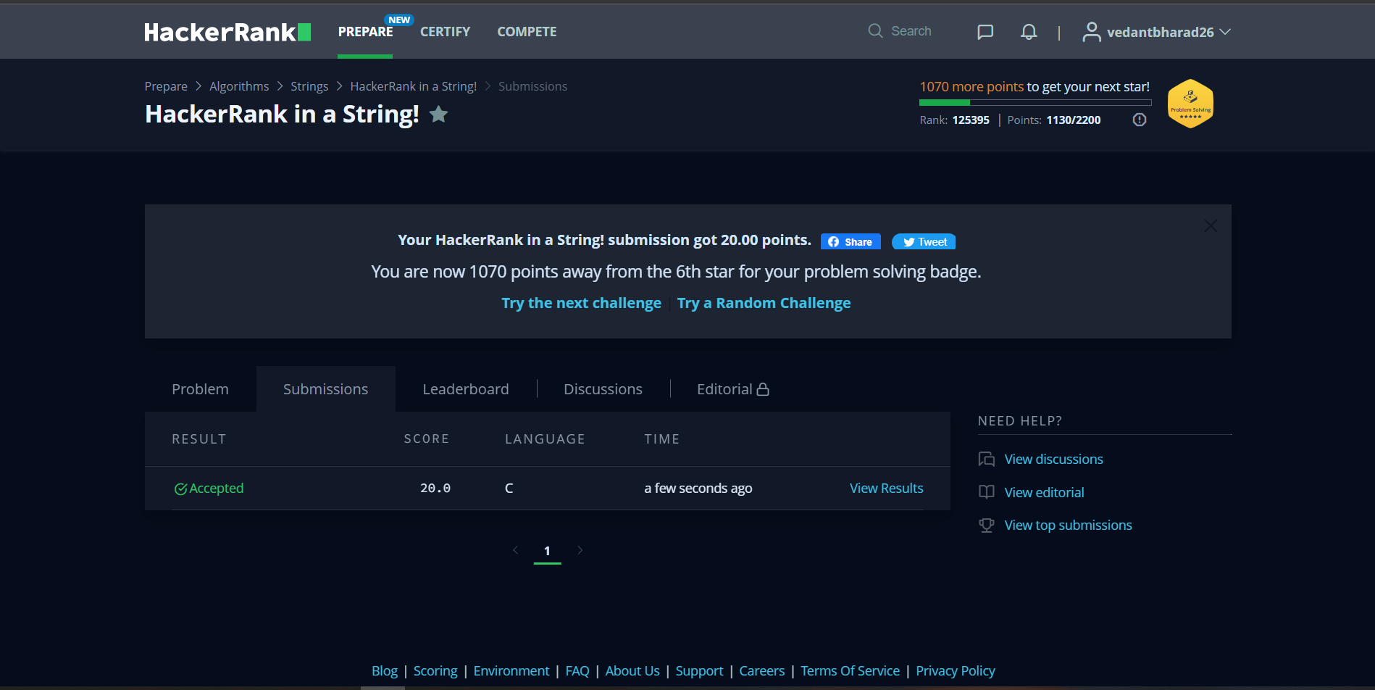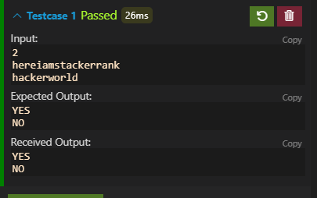

**Understanding about problem:**

* In this task there is one input which is string.
* In this task need to find hackerrank string in given string and if is there then return YES else NO.

Note: If you can't understand the problem, feel free to contact us and we'll help you. Please don't copy and paste from anywhere.

ALL THE BEST

Team CP Club